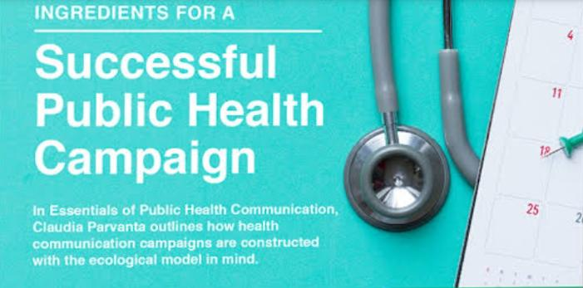Phase 3: Public Health Awareness

Introduction and Overview:

* Begin with an introduction to the public health issue your campaign addresses.
* Explain the importance of the campaign and the role of data visualization.
* Introduce IBM Cognos as the tool for visualizing campaign data.

Compaign analysis program using python:

Import pandas as pd

Import matplotlib.pyplot as plt

Import seaborn as sns

# Step 1: Data Loading

Data = pd.read_csv(‘campaign_data.csv’) # Replace with your data source

# Step 2: Data Cleaning and Preprocessing (if needed)

# Step 3: Data Analysis

Campaign_metrics = data.groupby(‘date’).agg({

‘engagement’: ‘sum’,

‘reach’: ‘sum’

})

# Step 4: Data Visualization

Plt.figure(figsize=(10, 6))

Sns.lineplot(data=campaign_metrics, x=’date’, y=’engagement’, label=’Engagement’)

Sns.lineplot(data=campaign_metrics, x=’date’, y=’reach’, label=’Reach’)

Plt.xlabel(‘Date’)

Plt.ylabel(‘Count’)

Plt.title(‘Campaign Performance Over Time’)

Plt.legend()

Plt.show()

# Step 5: Insights and Reporting (print or export as needed)

Campaign Data Visualization:

* Present visualizations depicting campaign reach, engagement, and effectiveness.
* Use graphs, charts, and maps to illustrate data related to target audience demographics, reach across various channels, and engagement levels.
* Describe how each visualization helps in understanding the campaign’s imp

Analysis and recommendations:

* Analyze the visualizations and draw insights about the campaign’s performance.
* Identify strengths and weaknesses, potential areas for improvement, and trends.
* Provide recommendations for optimizing the campaign based on the analysis.

Data Sources and Methodology

* Briefly describe the sources of data used for the campaign analysis.
* Explain the methodology employed to collect, clean, and analyze the data.
* Mention any challenges or limitations in the data collection process.
* Page 5: Key Metrics and KPIs
* Highlight the key performance indicators (KPIs) that were monitored during the campaign.
* Use visualizations to show how these metrics evolved over time.
* Discuss any notable changes or patterns observed.
* Page 6: Audience Segmentation
* Show visualizations that break down the campaign’s impact by different audience segments.
* Explain how this segmentation helps in targeting and tailoring future campaigns.
* Social media and methodology:
* If relevant, provide visualizations of social media engagement and sentiment.
* Discuss how social media played a role in the campaign’s success or challenges.
* Page 8: Conclusion and Next Steps
* Summarize the main findings and insights from the analysis.
* Discuss the overall impact of the campaign and whether it achieved its objectives.
* Outline the next steps, including potential improvements and strategies for future campaigns.
* References:
* Include a list of references, data sources, and tools used in the analysis.
* Visualization should be a central element in each section to make the data more accessible and informative.

